**Assignment 4**

**List out the required processes to be coded along with the required flow charts.**

1. **Patient Registration process:-**

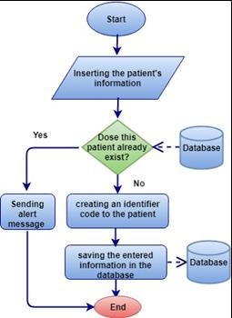

**Steps:**

**Collect patient information.**

**Validate and store patient details in the database.**

1. **Appointment Scheduling process:-**

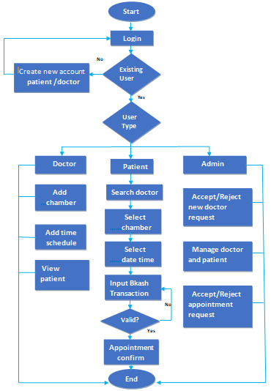

**Steps:**

**Receive appointment requests.**

**Check doctor availability.**

**Confirm or reschedule appointments.**

1. **Doctor Consultation Process:-**

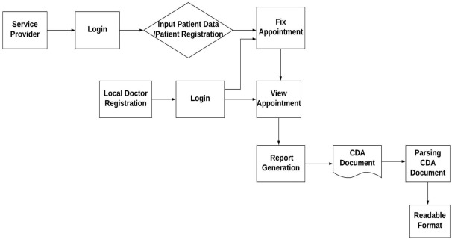

**Steps:**

**Retrieve patient information.**

**Conduct examination and diagnosis.**

**-Prescribe medications or order tests.**